Pendulum Lab

Name___________________________ Period____

Purpose: The purpose of this lab is to explore the relationship between the period of a pendulum and its amplitude, length, and mass. We will use this knowledge to construct a pendulum with a one second period.

Procedure: 1. Start Science Workshop in the AP Physics At Ease menu. Drag a Digital Plug icon to Digital Channel 1, scroll down and select Photogate and Pendulum. Drag a Table icon to Digital Channel 1 and select Period.

2. Set up a 75 cm long (length is measured to the center of mass of the pendulum) pendulum so that it blocks the photogate beam at the bottom of its swing.

3. Vary the amplitude of the 75 cm long pendulum as given in Data Table 1 and record the period in the space provided. Use a protractor to set the initial amplitude. It is a good idea to let the pendulum swing through 2 or more periods after you release it to let it settle down before recording the period.

4. Study your results from Step 3. How does amplitude affect the period of a pendulum?

5. Vary the length of the pendulum as given in Data Table 2 and record the periods in the space provided.

6. Trade pendulums with another group so that you have one with a significantly different mass and repeat step 5, recording the periods in the second column of Data Table 2.

Data Table 1 |  | Data Table 2
Mass=________ |  |  | Mass=________ | Mass=________
Amplitude | Period | Length | Period | Period
(deg) | (sec) | (m) | (sec) | (sec)
5 |  | 0.75
10 |  | 0.60
15 |  | 0.45
20 |  | 0.30
25 |  | 0.15

Q1: What affect does mass have on the period of a pendulum?

Q2: What affect does decreasing length have on the period of a pendulum?

Analysis: 1. Using the computer program Graphical Analysis, follow the instructions for plotting in panel 2 of the Fox Trot cartoon below. Use the data from either column of Data Table 2. Use the slope of your graph to calculate the percent error from the theoretical slope given in the cartoon. Show your work below.
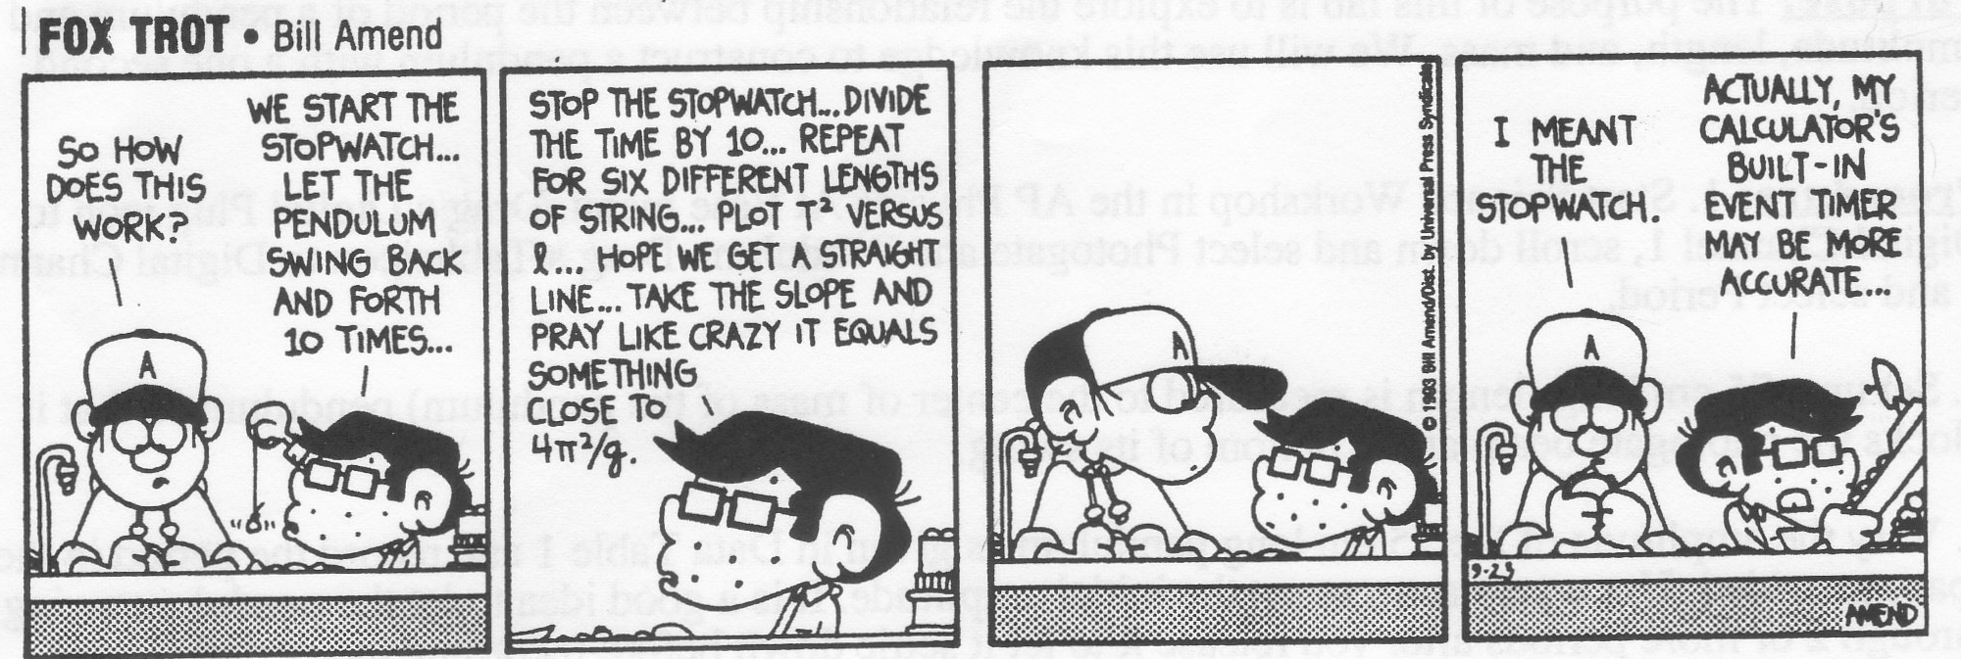

2. Write an equation for the period of a pendulum based on your graph and the theoretical slope given in the cartoon (not a number). Use y = mx +b where b should be zero. Solve it for the length of a pendulum with a 1 second period. Show your work then set up a pendulum and verify its period with the photogate. Calculate the percent error and show your work.

Q3: If you moved one of your pendulums to the top of Mt. Everest, would the period change? If so, how and why?

Q4: If you moved one of your pendulums to an orbiting Space Shuttle, would the period change? If so, how and why?

